Exercise 13: Connecting MongoDB with NodeJS

Objective
Connecting MongoDB with Node.js is a fundamental skill for backend development, allowing you to interact with your MongoDB database directly from your Node.js applications. This integration enables you to perform CRUD operations, manage collections, and use MongoDB’s powerful querying capabilities. In this exercise, you’ll learn when you start connecting MongoDB with Node.js.

Exercise
- Install mongo version 6.4.0
- Code is used to declare url and database of Mongo
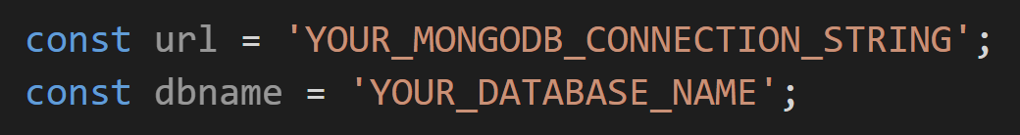
- Create file operation.js and do CRUD with mongodb
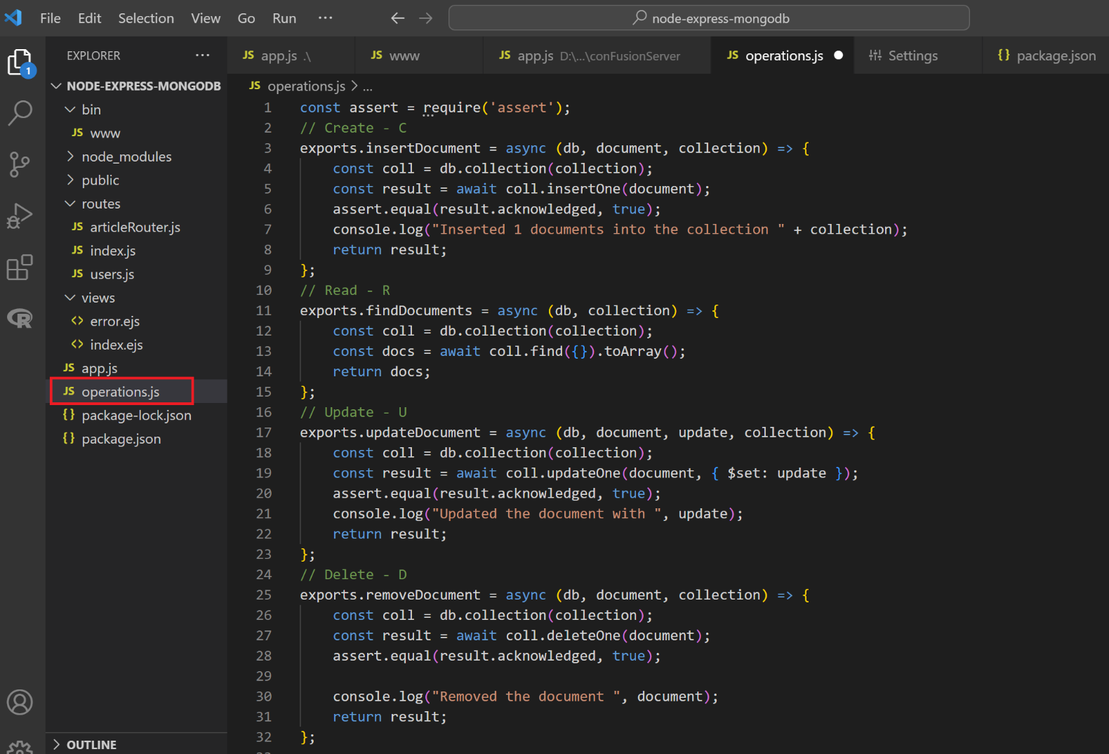
- add the following code in app.js:

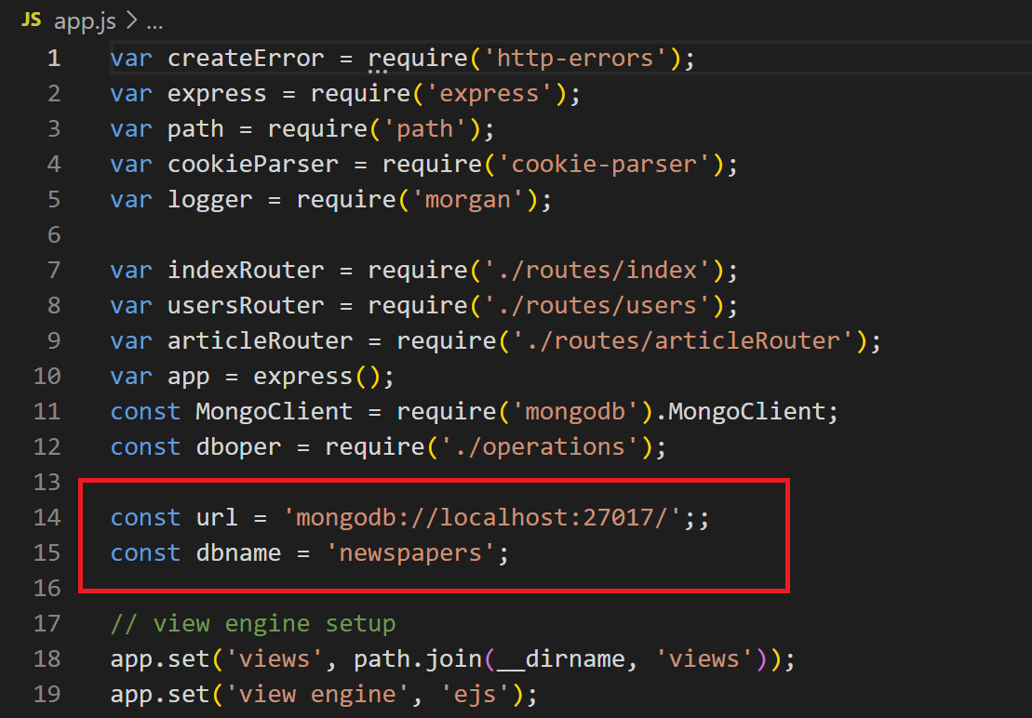

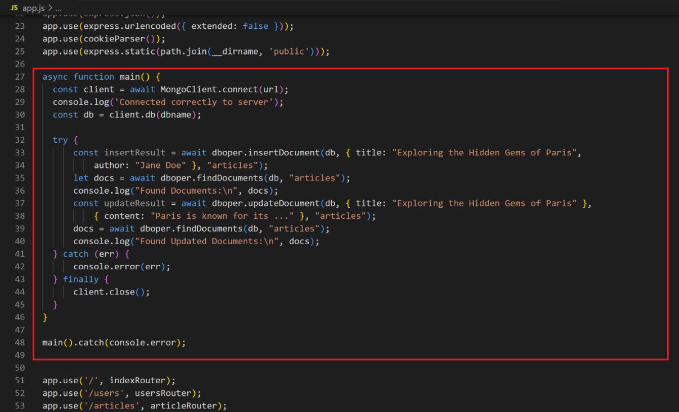

- Result
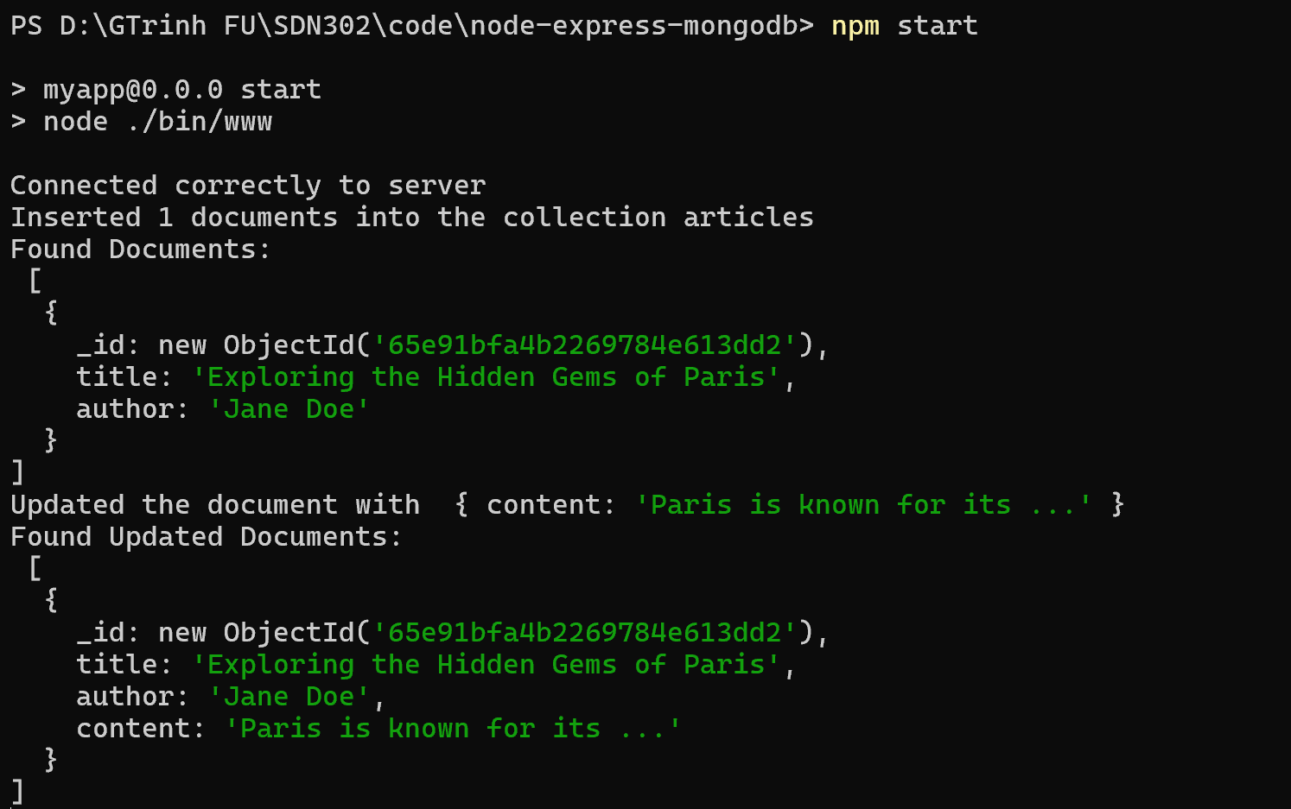

Exercise 2: Do again exercise 1 and 2 in exercise 14 with nodejs

Conclusion
This exercise aims to learn how to connect MongoDB with Node.js, you’ll gain the skills needed to build scalable, data-driven applications. This knowledge is applicable to a wide range of applications, from simple websites to complex, high-traffic services.

